**Entity-Relationship**

**Entities in the Project:**

* Bot
* User

**Attributes of entities:**

* **User**- name, password, username (primary key), email (primary key), phone number
* **Bot**- OTP, name

**Relationship between User and Bot:**

* Bot ***supports*** the User

**Entity-Relationship Diagram (ER-Diagram):**

*USER:*

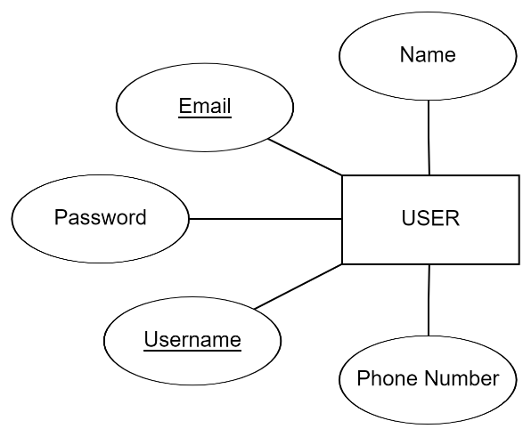

*BOT:*

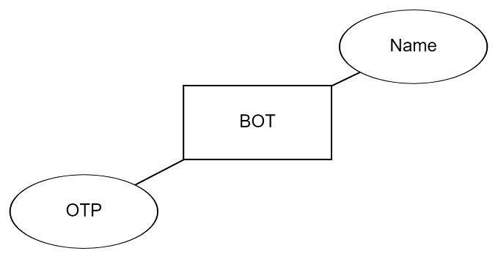

**BOT SUPPORTS USER**

